**MODEL DEVELOPMENT**

Learning objectives:

* Simple and multiple linear regression
* Model evaluation using visualization
* Polynomial regression and pipelines
* R-squared and MSE for in-sample evaluation
* Prediction and decision making
* A model can be thought of as a mathematical equation used to predict a value given one or more other values
* Relating one or more independent variables to dependent variables
* Usually, the more relevant data you have the more accurate your model is.

**LINEAR REGRESSION AND MULTIPLE LINEAR REGRESSION**

Linear regression will refer to 1 independent variable to make a prediction

Multiple linear regression will refer to multiple independent variables to make a prediction

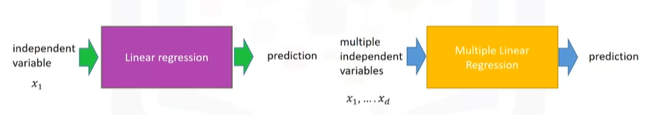

**SIMPLE LINEAR REGRESSION (SLR)**

1. The predictor (independent) variable – x
2. The target (dependent) variable – y

With: b0: the intercept and b1: the slope

**FITTING A SLR ESTIMATOR:**

X: predictor variable

Y: target variable

1. Import linear_model from scikit-learn

From sklearn.linear_model import LinearRegression

1. Create a linear regression object using the constructor

lm=LinearRegression()

We define the predictor variable and target variable

X = df[[‘highway-mpg’]]

Y = df[‘price’]

Then use lm.fit(X, Y) to fit the model, i.e fine the parameter b0 and b1

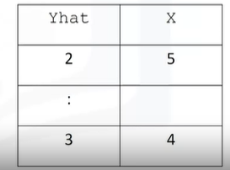lm.fit(X, Y)

We obtain a prediction

Yhat = lm.predict(X)

**MULTIPLE LINEAR REGRESSION (MLR)**

**Fitting a multiple linear regression (MLR)**

1. We can extract the 4 predictor variables and store them in the variable Z

Z = df[[‘horse-power’, ‘curb-weight’, ‘engine-size’, ‘highway-mpg’]]

1. 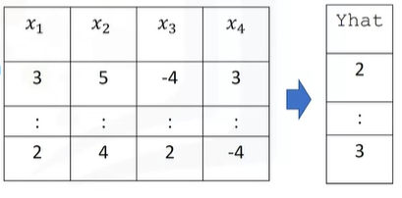Then train the model as before

lm.fit(Z, df[‘price’])

1. We can also obtain a prediction

Yhat = lm.predict(X)

Find the intercept (b0): lm.intercept_

Find the coefficients (b1, b2, b3, b4): lm.coef_

**REGRESSION PLOT:**

Regression plot shows us a combination of:

The scatterplot: where each point represents a different Y

The fitted linear regression line (Yhat)

Import seaborn as sns

Sns.regplot(x = “highway-mpg”, y = “price”, data= df)

Plt.ylim(0,)

**RESIDUAL PLOT**

Import seaborn as sns

Sns.residplot(df[‘highway-mpg’], df[‘price’])

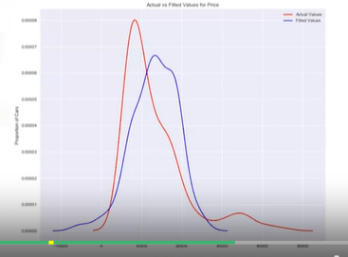

**DISTRIBUTION PLOTS**

Compare the distribution plots:

The fitted values that result from the model

The actual values

Import seaborn as sns

Ax1 = sns.displot(df[‘price’], hist= False, color=”r”, label= “Actual Value”)

Sns.displot(Yhat, hist= False, color= “b”, label= “Fitted Value”, ax=ax1)

**POLYNOMIAL REGRESSION AND PIPELINES**

**POLYNOMIAL REGRESSION**

A special case of the general linear regression model

Useful for describing curvilinear relationships

Curvilinear relationships:

By squaring or setting higher-order terms of the predictor vartiables

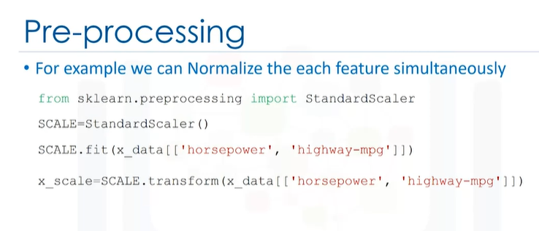

**PIPELINES:**

From sklearn.preprocessing import PolynomialFeatures

From sklearn.linear_model import LinearRegression

From sklearn.preprocessing import StandardScaler

From sklearn.pipeline import Pipeline

Blue: name of the estimator – model

Red: model constructor

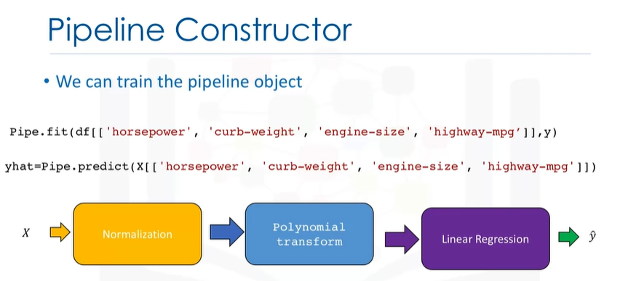

**MEASURE FOR IN-SAMPLE EVALUATION**

* A way to numerically determine how good the model fits on dataset
* Two important measures to determine the fit of a model
* Mean squared error (MSE)
* R-squared (R2)

**Mean squared error (MSE)**

In python, we can measure the MSE as follows

From sklearn.metrics import mean_squared_error

Mean_squared_error(df[‘price’], Y_predict_simple_fit)

**R-squared (R2)**

The coefficient of determination or R-squared (R2)

Is a masure to determine how close the data is to the fitted regression line

R2: the percentage of variation of the target variable (Y) that is explained by the linear model

Think about as comparing a regression model to a simple model i.e the mean of the data points

Generally, the values of the MSE are between 0 and 1.

We can calculate the R2 as follows:

X = df[[‘highway-mog’]]

Y = df[‘price’]

Lm.fit(X, Y)

Lm.score(X, Y)

**PREDICTION AND DECISION MAKING**

**DECISION MAKING: DETERMINING A GOOD MODEL FIT**

To determine final best fit, we look at a combination of:

* Do the predicted values make sense
* Visualization
* Numerical measures for evaluation
* Comparing models

**Comparing MLR and SLR**

MSE for MLR model will be smaller than the MSE for a SLR model, since the errors of the data will decrease when more variables are included in the model

Polynomial regression will also have a smaller MSE than the linear regular regression

Now that we have visualized the different models, and generated the R-squared and MSE values for the fits, how do we determine a good model fit?

* What is a good R-squared value?

**When comparing models, the model with the higher R-squared value is a better fit for the data.**

* What is a good MSE?

**When comparing models, the model with the smallest MSE value is a better fit for the data.**